
Symbiosis Institute of Technology, Pune
Faculty of Engineering
CSE- Academic Year 2026-27
Java Programming – Lab Batch 2024-28
Lab Assignment No:- 18
Name of Student: Sanika Botre
PRN No.: 25070122063
Batch: 2025-29
Class: CSE A-2
Academic Year & Semester: 2026 & 3rd Semester
Date of Submission
Title of Assignment: Write a Java GUI program to demonstrate button click event handling.

Learning Objectives: To implement button click events using Java event handling mechanisms.

Theory: Event handling allows Java programs to respond to user actions such as button clicks, mouse movements, and keyboard input. Swing uses ActionListener to process button click events. Event-driven programming separates user interface design from event-processing logic, making applications interactive and user-friendly.
Practice questions
1. Create a GUI calculator where buttons perform addition and subtraction.
Code:
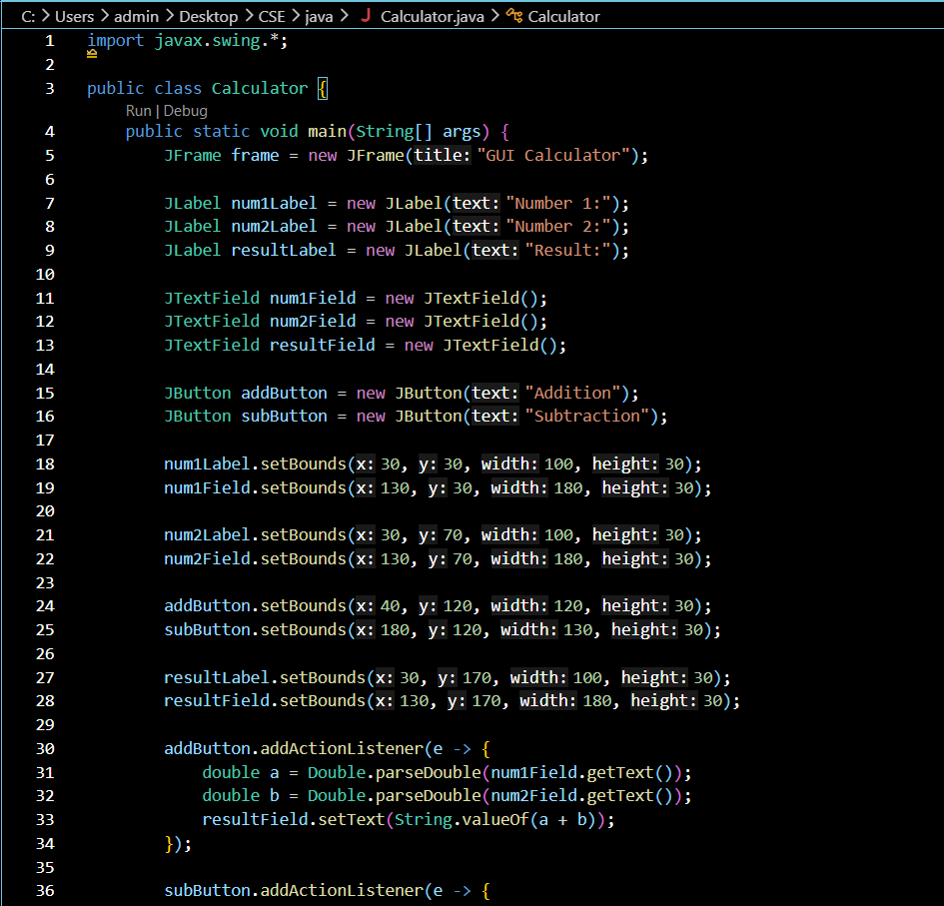
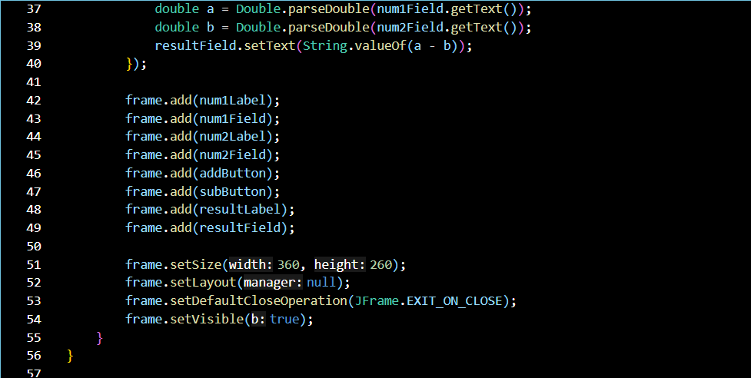

Output:
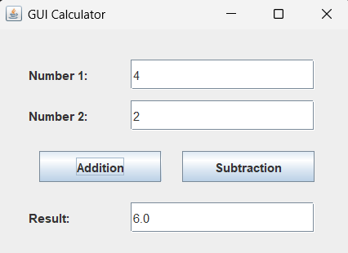
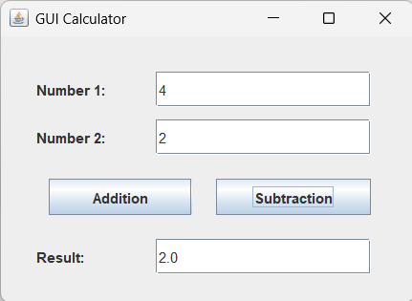

2. Create a Bank Balance Calculator GUI application using Java Swing where the user enters the initial balance and transaction amount. Use buttons to perform addition (deposit) and subtraction (withdrawal) and display the updated balance.
Code:
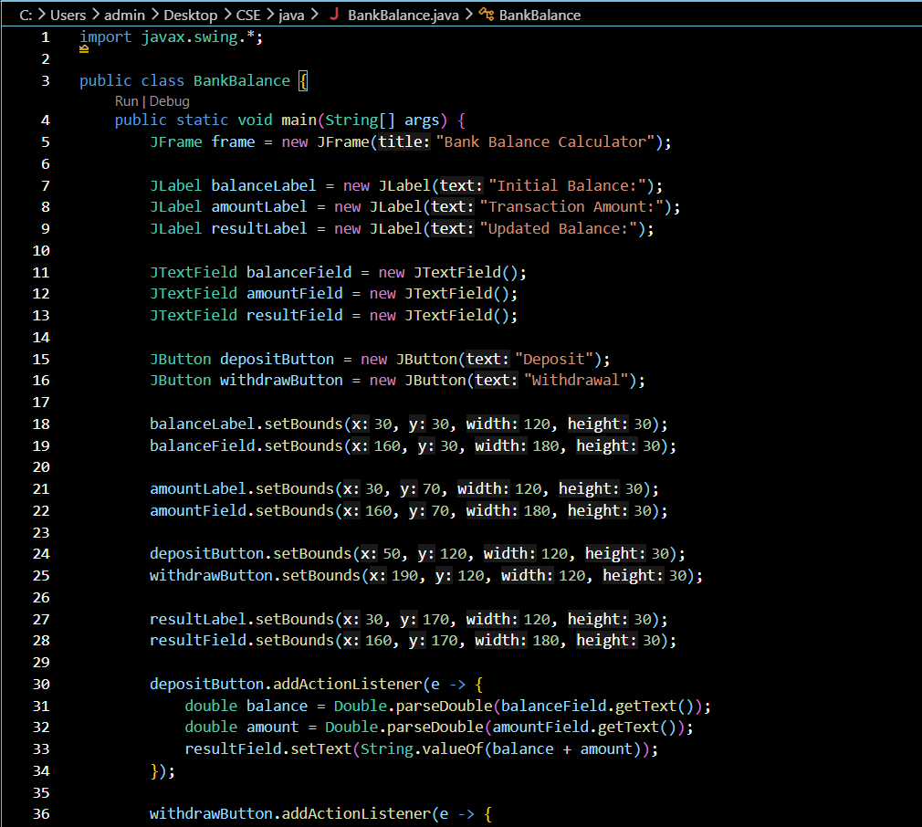

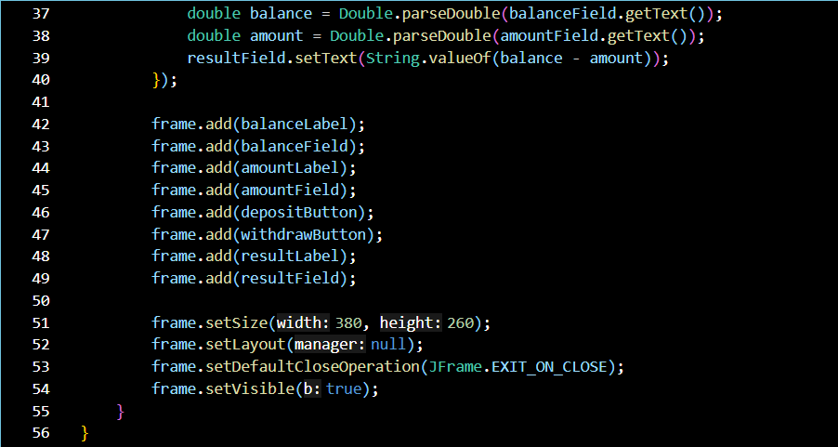

Output:
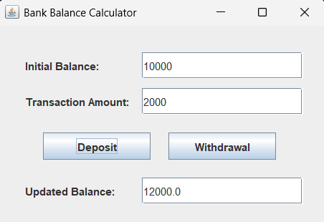
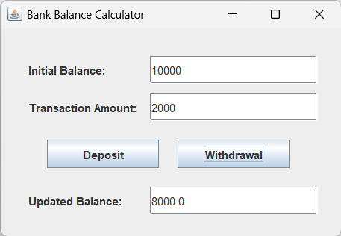

Conclusion
Thus, the Bank Balance Calculator GUI application was successfully designed and implemented using Java Swing. The application accepts the initial balance and transaction amount from the user and provides Deposit and Withdrawal buttons to perform addition and subtraction respectively. The updated balance is displayed in the GUI after each transaction. This assignment demonstrates the use of Swing components and button click event handling in Java.

